The Cartesian Plane

If you take one number line and place it at right angles to another number line, you’ve set up a two dimensional plane. We name this one after the French mathematican Decartes. There are many other planes out there; google Argand Plane for another (named for a Norwegian mathematician). We divide the plane into 4 quadrants with boundaries that are the axes, the numberlines.
In Quadrant 1 both coordinates are positive (+, +). In Quadrant 2 the x coordinate is negative and the y is positive (−, +). Both coordinates are negative in Quadrant 3 (−, −) and in Quadrant 4 the x coordinate is positive and the y coordinate is negative (+, −).
Points on the x axis have the y coordinate equal to zero. On the y axis, the situation is reversed and the x coordinate is zero. These points are not in ANY quadrant but are on the boundaries. They are called quadrantal points.
A vertical line through the point (3, 0) is called “x = 3” because the x coordinate will always be 3 and the y coordinate will vary. This is called a line as a courtesy as the slope is undefined and it doesn’t fit into the line formula y = mx + b. Check this fact out with (3, 5) and (3, 7) in the slope formula.
A horizontal line has a slope of zero so that term disappears from the equation and, for example if the line includes the point (0, 5), it will be called y = 5, the “mx” term disappears since m = 0. Check this out with the slope formula and (3, 5) along with (3, 7).
If you know the equation of a line and a value of one coordinate you can calculate the value of the missing coordinate fairly easily.

Given the point (x, −8), calculate the x value for y = 5x + 12.

Let’s look at a few examples of lines.

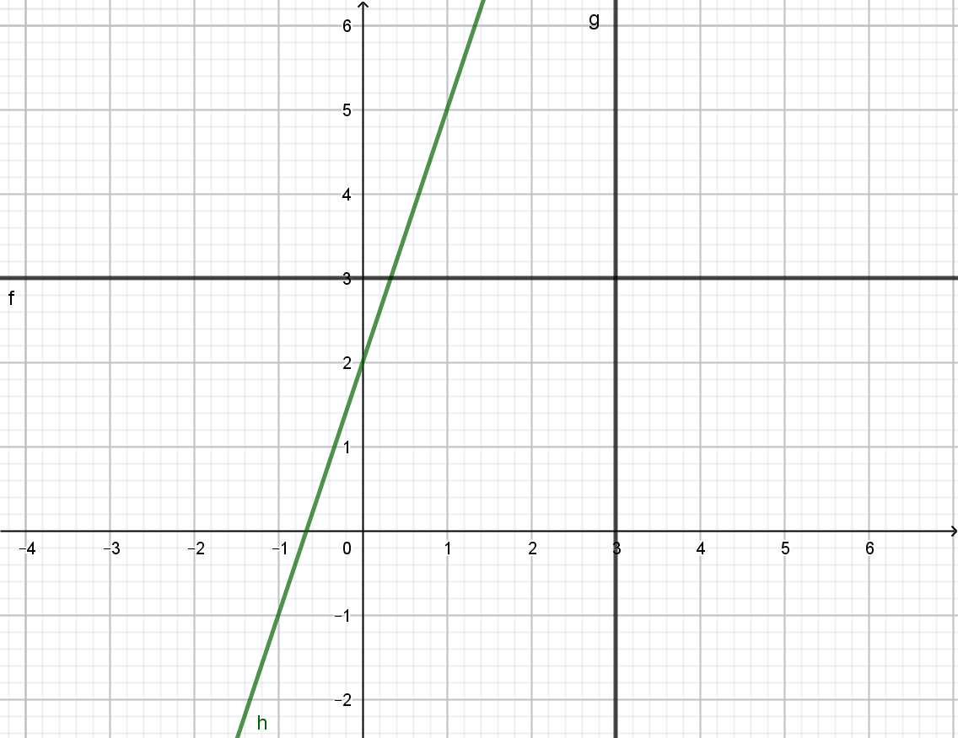
Which of the above is

y = 3, x = 3, and y = 3x +2?

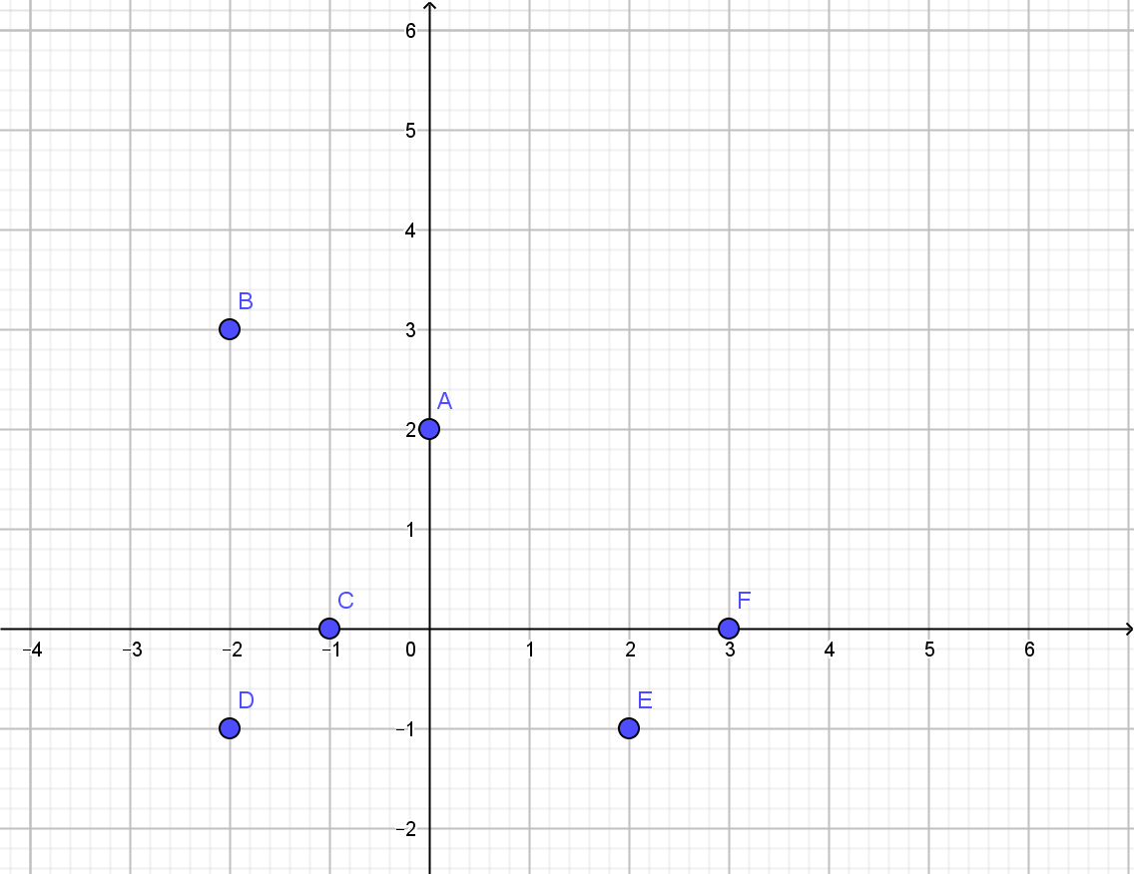

Pick out which of the following descriptors go with which point.

Quadrantal points
(0, +) (+, +)
(θ, −) (+, −)
(−, 0) (−, +)
(+, 0) (−, −)

Fill in the table for the points that are on the line y = −x +12.

x | y
2
 | -9
0

What is that third point called, officially?

Take this to CASA or email me for help!

